GRAFICA DE BARRA GENERAL

INSTITUCONES POR REGIONES

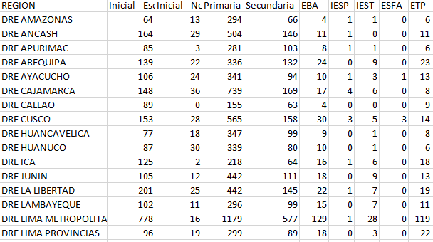

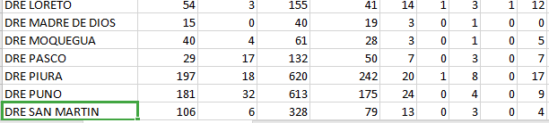

|  |  |  |  |  |
| --- | --- | --- | --- | --- |
| REGION | INICIAL | PRIMARIA | SECUNDARIA | ESPECIAL |
| DRE AMAZONAS | 1371 | 3774 | 2975 | 33 |
| DRE ANCASH | 3266 | 8623 | 8679 | 155 |
| DRE APURﾍMAC | 1587 | 3824 | 3651 | 40 |
| DRE AREQUIPA | 4350 | 8675 | 8985 | 217 |
| DRE AYACUCHO | 2162 | 6100 | 5725 | 42 |
| DRE CAJAMARCA | 4135 | 12310 | 10226 | 93 |
| DRE CALLAO | 2750 | 5177 | 4456 | 217 |
| DRE CUSCO | 3016 | 9169 | 8561 | 141 |
| DRE HUANCAVELICA | 1562 | 4134 | 4121 | 51 |
| DRE HUANUCO | 2028 | 6034 | 5146 | 35 |
| DRE ICA | 2771 | 5167 | 5164 | 91 |
| DRE JUNﾍN | 3453 | 9546 | 9352 | 97 |
| DRE LA LIBERTAD | 5095 | 11597 | 10281 | 156 |
| DRE LAMBAYEQUE | 2940 | 7486 | 6791 | 91 |
| DRE LIMA METROPOLITANA | 23458 | 45160 | 43050 | 1462 |
| DRE LIMA PROVINCIAS | 2667 | 6547 | 6591 | 175 |
| DRE LORETO | 3291 | 7928 | 5477 | 122 |
| DRE MADRE DE DIOS | 443 | 895 | 860 | 10 |
| DRE MOQUEGUA | 571 | 1297 | 1458 | 41 |
| DRE PASCO | 788 | 2261 | 2412 | 33 |
| DRE PIURA | 4770 | 11073 | 9728 | 146 |
| DRE PUNO | 3083 | 9623 | 9716 | 73 |
| DRE SAN MARTIN | 2187 | 5634 | 4713 | 64 |
| DRE TACNA | 914 | 1846 | 2365 | 39 |
| DRE TUMBES | 862 | 1626 | 1569 | 81 |
| DRE UCAYALI | 1249 | 3401 | 2998 | 75 |

GRAFICA DE BARRAS GENERAL

PROFESORES EN LA EDUCACION BASICA INCLUSIVA

GRAFICA DE BARRA

|  |  |  |  |  |
| --- | --- | --- | --- | --- |
| REGION | INICIAL | PRIMARIA | SECUNDARIA | ESPECIAL |
| DRE AMAZONAS | 1371 | 3774 | 2975 | 33 |
| DRE ANCASH | 3266 | 8623 | 8679 | 155 |
| DRE LAMBAYEQUE | 2940 | 7486 | 6791 | 91 |
| DRE LIMA METROPOLITANA | 23458 | 45160 | 43050 | 1462 |
| DRE TUMBES | 862 | 1626 | 1569 | 81 |
| DRE UCAYALI | 1249 | 3401 | 2998 | 75 |

|  |  |  |  |  |  |  |  |  |  |
| --- | --- | --- | --- | --- | --- | --- | --- | --- | --- |
| REGION | Inicial - Escolarizada | Inicial - No Escolarizada | Primaria | Secundaria | EBA | IESP | IEST | ESFA | ETP |
| DRE AMAZONAS | 64 | 13 | 294 | 66 | 4 | 1 | 1 | 0 | 6 |
| DRE ANCASH | 164 | 29 | 504 | 146 | 11 | 1 | 0 | 0 | 11 |
| DRE LAMBAYEQUE | 102 | 11 | 296 | 99 | 15 | 0 | 7 | 0 | 11 |
| DRE LIMA METROPOLITANA | 778 | 16 | 1179 | 577 | 129 | 1 | 28 | 0 | 119 |
| DRE TUMBES | 28 | 5 | 46 | 30 | 4 | 1 | 1 | 0 | 4 |
| DRE UCAYALI | 27 | 3 | 83 | 22 | 9 | 0 | 1 | 0 | 6 |